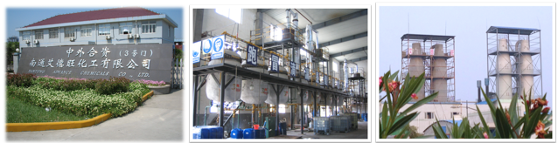
Di-n-butyltin Di(Monobutyl Maleate)
(BT-53C)
- CAS No: 66010-36-4
- Molecular formula: C₂₄H₄₀O₈Sn
- Trait：Yellow oily liquid
- Structural formula: 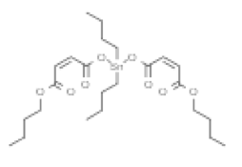
- Quality indices
Item | Index
Tin content（%） | ≥16.0
Specific gravity（20℃） | 1.15-1.30
Index of refraction （25℃） | 1.4850-1.4950

- Annual Producing Capacity: 5,00Ton/Year.
7. Purpose: This chemical product is non-toxic. As a thermal stabilizer for transparent PVC products, it features satisfactory thermal stability, weather resistance, transparency and coloring resistance. Besides, it is characteristic of little tearing property, fast gelation and no sulfurized pollution. It is mainly applicable to hard transparent boards, membranes, thin sheets, injection plastic products, and hollow molded products. The dose is 2.0~4.0.
8. Package: 200kg steel plastic drum
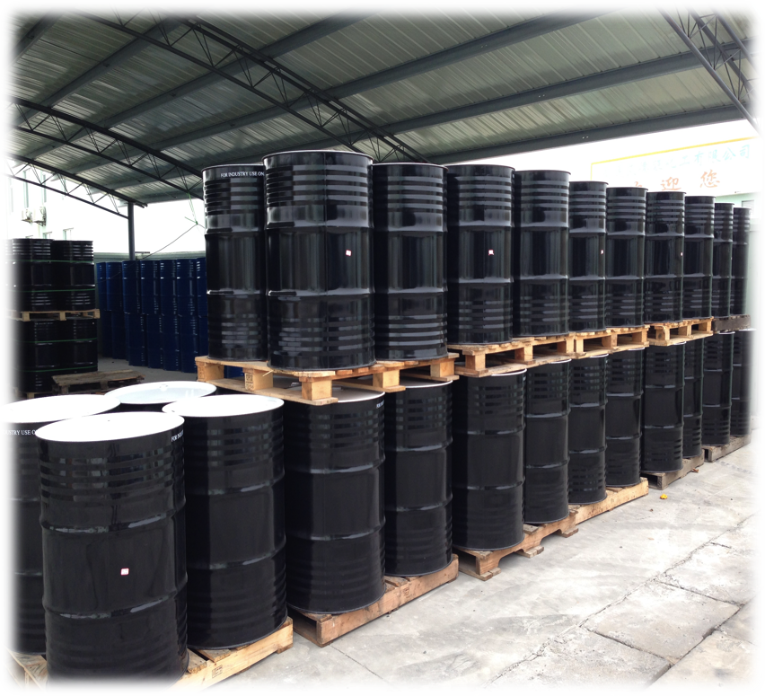
- Storage and personal protection:
Store in a cool, dry and ventilated place, keep the container sealed. Storage period 18 months.
Prevent entry into the mouth or eyes, splashed on the skin must be washed with flowing water minimum 15mins. Workplaces must have good ventilation. Prevent the inhalation of steam and smoke.

