SICHUAN BLUE SWORD CHEMICAL CO.,LTD
CERTIFICATE OF ANALYSIS

Product: DIAMMONIUM PHOSPHATE (FOOD GRADE)
Standard executed: HG/T4132-2010 Manufacture Date: 2016-04-6
Quantity: 25MT Analysis Date : 2016-04-6
Package: 25KG/bag Expiry Date : 2018-04-6
Item | Specifications | Test resul
Appearance | White Crystal | White Crystal
Main contents % ≥ | 99 | 99.25
P₂O₅ % ≥ | 53 | 53.08
N % ≥ | 20.8 | 21.08
Moisture % ≤ | 0.2 | 0.16
Water insoluble % ≤ | 0.1 | 0.06
PH of 1% water solution | 7.6-8.2 | 7.92
Arsenic % ≤ | 0.0003 | 0.0001
Heavy metals, as Pb % ≤ | 0.001 | 0.0007
 | 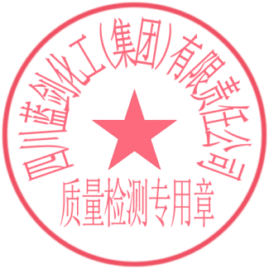

Inspected: Daijing Luguo Checked: Chenchen

